**Controller Classes**

Different types Of Controller Classes provided by the struts framework’

1. Action Class: These are useful when performing single button action.
2. DispatchAction Class: Useful while performing multi-button operations but can’t give support for multiple languages and hence are not useful the projects which requires the multiple language support i.e. we don’t have internationalization support here.

For example

Consider example below

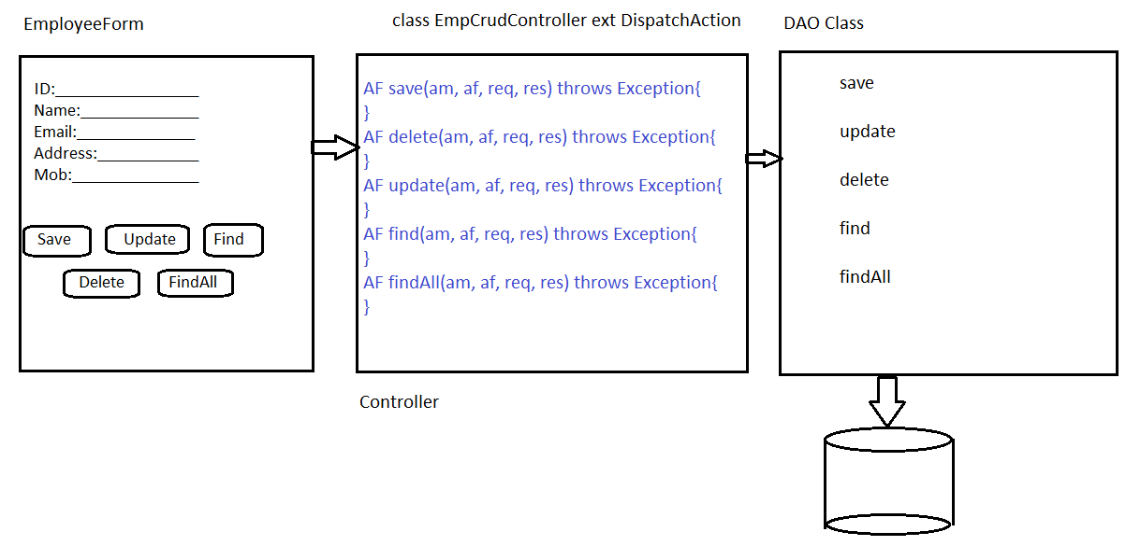

We have 5 different buttons with different labels on them so in our dispatchAction Class must contain the 5 methods with name as that of values of buttons on the front end and signatures should be same as that of an Action Controller Class.

The save method must be declared as follows:

ActionForm save(ActionMapping am, ActionForm af, HttpServletRequest req, HttpServletResponse res) throws Exception

But if we apply I18N support for the same example like English, Hindi, Telugu etc. then on changing the language of the form button value will also be changed and ActionServlet will throw an error NoSuchMethod Exception.

The Execute method will try find the button value for a specific button and after finding the button value it will delegate the task to the Dispatch() and using reflection it will try to find the method related to the given the button value. If it finds the button value then it will redirect the request from the Dispatch method to the method found by it. If in case it doesn’t find any method with same name it throws the NoSuchMethodException

1. LookupDispatch: Along with the multi-button support. it also supports for the I18N.
2. EventDispatch: This Controller class also support both the features i.e. multi-button and I18N Support.

In above example if we extend our class with LookupDispatchAction Class and if we providing the I18N Support, the execute method will read the say Hindi value of a button. After reading Hindi value it will find the proper key value from properties file. So function of execute() method of LookupDispatch class is 1. Finding the value for a button and 2. Finding the corresponding key for the same value from properties file.

Unlike DispatchAction Class where the method name corresponding a button should be the same as button value, we don’t have to write the method name same as that of a button value. Instead we have a method called getKeyMethodMap() with return value map which maps the key in properties file of a button value to the method name as we have defined in our LookupDispatchAction class.

For example

Map getKeyMethodMap(){

Map m= new HashMap();

m.put(“add”,”addtion”);

m.put(“sub”,”subtraction”);

return m

}

Implementation of EventDispatchAction Class

If we extend our action Class with EventDispatchAction class then we have to parametirased each of the buttons on form giving some name to the buttons and methods in the EventDispatchClass should have same name as the button parameter id. In struts-config.xml file we have to configure our each submit buttons by configuring the parameter separated by the commas.

<action parameter=”add, subtract, divide, multiply”/>

The execute method will split this into substrings and will get four strings and will also get the value of a button on the form and if the value on the button is one among the substrings created by the execute method then It will delegate the task to the method having same name say if button add is clicked on the form then execute method will get add value from that button and hence will request add method to carry out the task.

Implenatation of MappingDispatchAction Class: It is used when we want to implement our multiple forms with single controllers. It is useful when we are mapping only one submit button from multiple forms otherwise it’s of no use.